

Sarah and Calum have some sweet in jars.

Who made equal groups?

Explain how you know.

____________________________________________________________________________________________________________________________________

Calum

Sarah

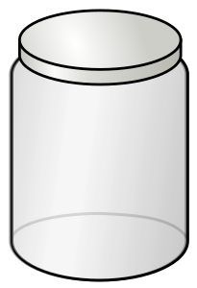

Sarah and Calum have some sweet in jars.

Who made equal groups?

Explain how you know.

____________________________________________________________________________________________________________________________________

Calum

Sarah





Sarah and Calum have some sweet in jars.

Who made equal groups?

Explain how you know.

____________________________________________________________________________________________________________________________________

Calum

Sarah

